Factory & Labour Inspection Manual
1. In ADF/DDF Account, there is a menu named “Inspections”. On clicking the menu, It will redirect to Randomization dashboard.
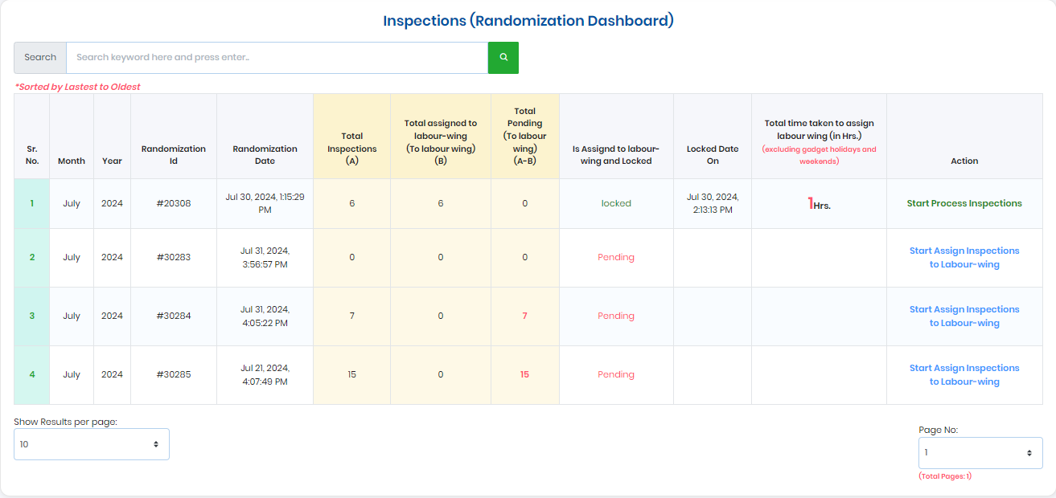
- Here officials can see all the randomized inspections for their circle year and month wise. Number of inspections assigned and pendency’s.
- There is a column named “Total time taken to assign labour wing (in Hrs.)” to represent total hours (excluded Gazetted Holidays & Weekends) taken by factory wing officials to assigned inspection to labour inspectors.
- If the inspections are assigned to inspectors, then “Start Process Inspection” Button is showing. And if the inspection are pending to be assigned then “Start Assign Inspections To Labour Wing” Button is showing. Please refer the above snapshot for the same.
2. On Click of “Start Assign Inspections To Labour Wing” It will redirect to Inspection confirmation page.
- The Inspection confirmation page shows that the total Factories along with their Name & Address were randomized and allotted to one official.
- Inspection-Status column show the current status of Factory weather it is Assigned or UnAssigned.
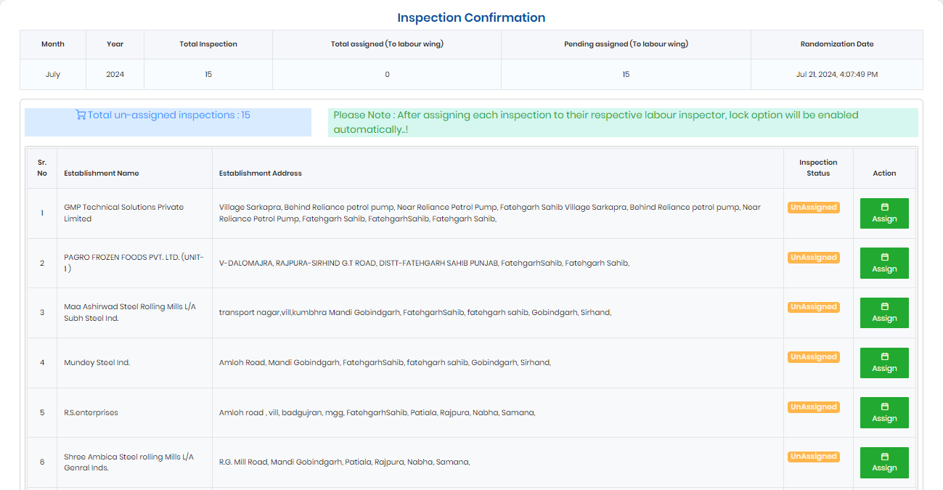
3. On Clicking the Assign Button, a popup is showing along with the inspector’s details. Officer can Allotted the particular inspector to whom that Establishment (Factory) is belong (as per the jurisdictions) to process the inspection.
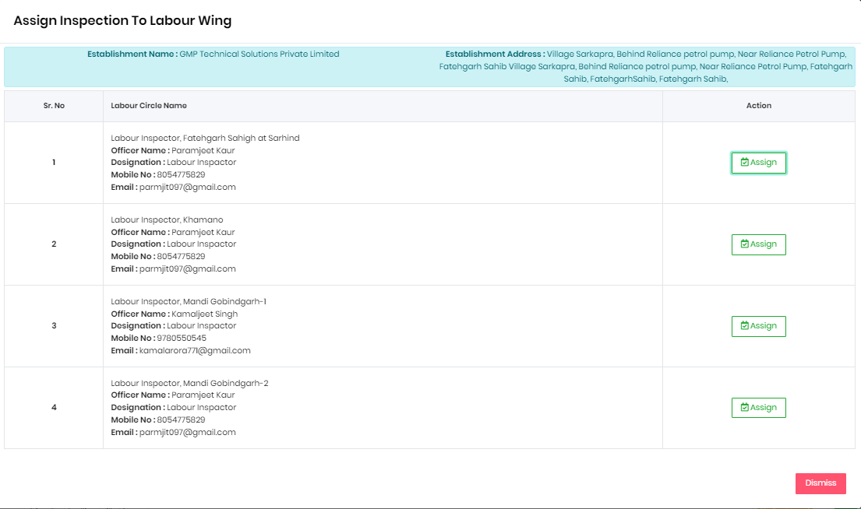
- Once the Inspections of that Factory is assigned successfully, they will show on the Inspection Confirmation Dashboard. Please see the below snapshot for the same.
- Here Re-Assigned Button is showing for in case officers assigned to wrong inspectors.
- Once officer assigned all the inspections to respective inspectors, then the lock inspection button is showing automatically.
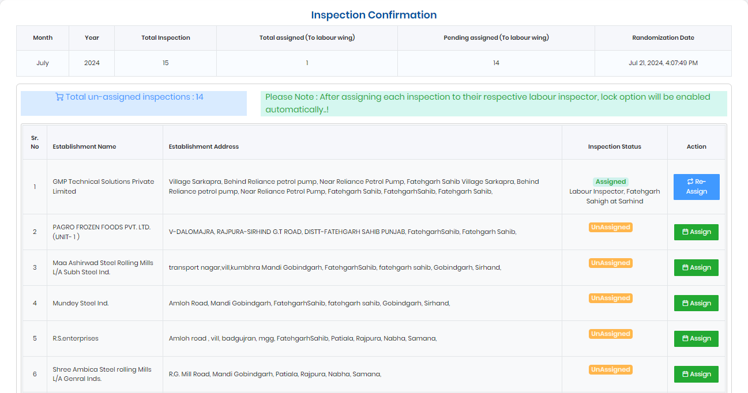
4. After Assigning and locking all the inspections, it will be redirected to “Inspection Process Dashboard”. Here officials can see all the inspections details.
- In this dashboard, officers can see the inspections details of both. If inspector filled out the inspection then the details show in the column named “Labour -Wing” along with the total time taken.
- This dashboard is showing to both ADF/DDF & Inspector. They can see the details like total time taken by ADF/DDF to assign the inspection and total time taken by the inspectors to process the inspections.
ADF/DDF Dashboard -
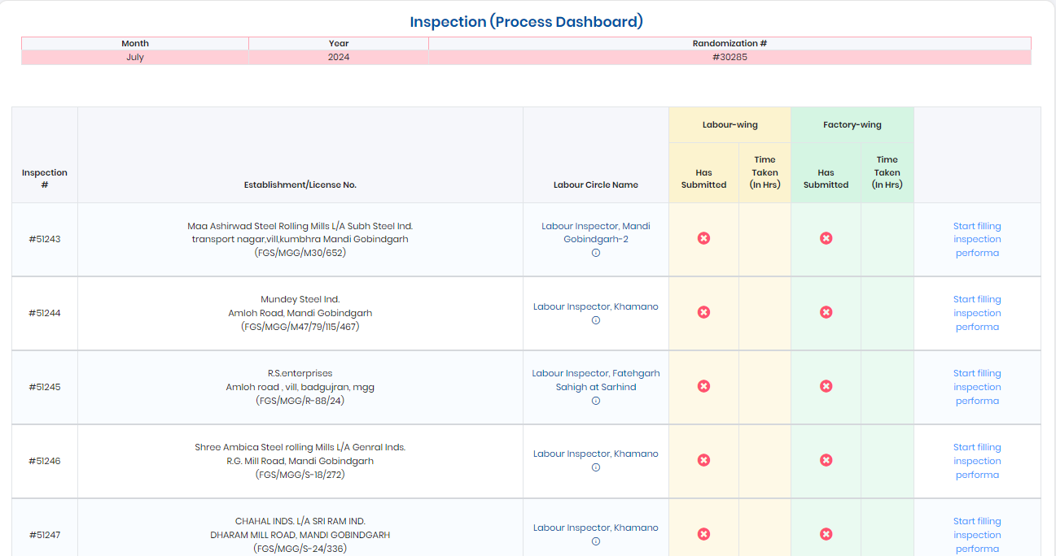
5. On clicking the “Start Filling Inspection Performa” button, it will redirect to establishment operational status dashboard.
- Here, the officers select the “Factory Operational Status” If the Factory is currently operational, then only button for “Start Filling Inspection Performa” is enabled.
- If the Factory status is not currently operational, then officer can provide the details like “Inspection Date”, “Establishment Type”, “Factory De-Register No” and “Remarks” and submit the inspections.
- On-clicking on “Start Filling Inspection Performa” it will redirect to the Factory & Labour inspection Performa page according to the officers. If ADF/DDF filling out the inspections then he/she need to fill the Factory Inspection Performa and if the Labour Inspectors filling the inspections then he/she need to fill out the Labour Inspection Performa.
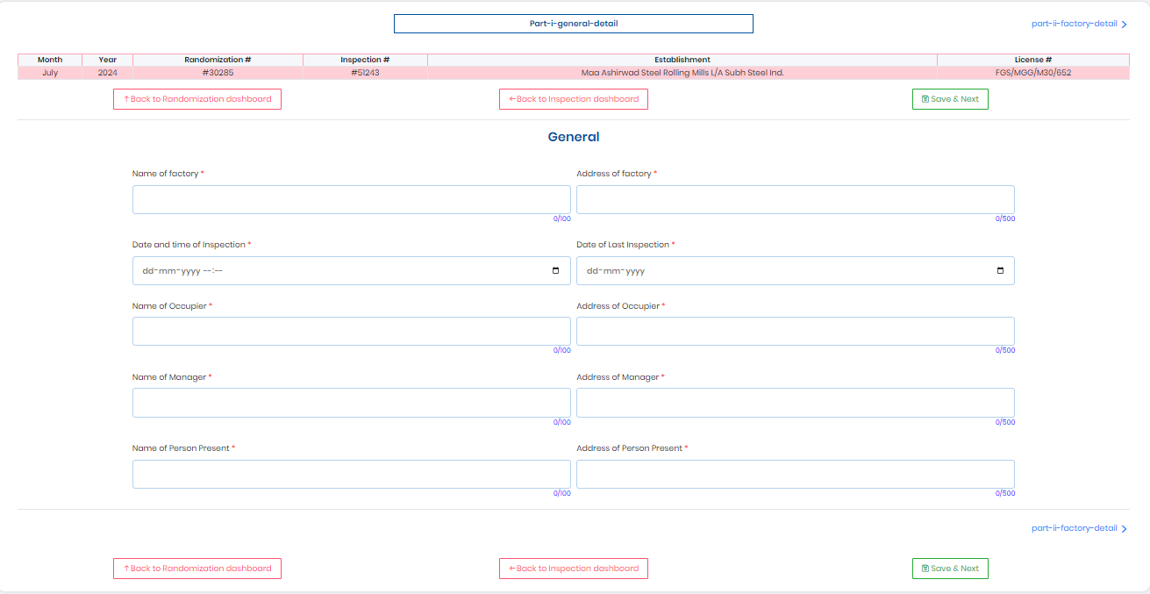
- There is a stepper showing on the top of the page that shows total no of Performa pages. It will show the steps of Performa pages. If any page is filled, then their status is completed from “Pending” To “Filled”. Officer can jump any page on click of “Go to this step” button.
- Once all the Performa steps are completed, then “Lock Inspection” button is appear automatically.
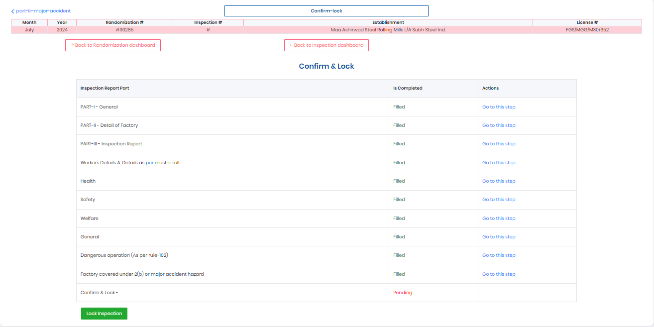
6. After lock the inspection it will redirected to the “Process Inspection Dashboard”.
- In this dashboard, officers can see the inspections details of both. Inspection Filled By Inspector details show in the column named “Labour -Wing” along with the total time taken in hours and ADF/DDF inspection time taken in showing under column named “Factory -Wing”.
